WEEK 6 FINAL REPORT
Model Evaluation and Final Verification
Exploring Customer Feedback and Product Sentiment
Internship | Data Science with Python Analyst Internship
Domain | Beauty & Wellness
Stage | Week 6 — Evaluation
Report date | 6 November 2026 (as recorded in README)
Evaluation model | Logistic Regression
This report documents the saved-prediction evaluation, metric interpretation, class-level errors, confusion-matrix verification, generated outputs, limitations, and final submission checks.

Report contents
Executive Summary; Project Objectives; Input Data and Workflow; Evaluation Metrics; Confusion Matrix and Verification; Class-Level Classification Report; Output Files and Evidence; Limitations and Improvements; Conclusion and Checklist.

1. Executive Summary

Purpose of Week 6
Week 6 is the model-evaluation and final-verification stage of the project “Exploring Customer Feedback and Product Sentiment.” The work evaluates the saved predictions from Week 5 rather than training a new classifier. The notebook reads the saved prediction CSV, compares actual star ratings with model predictions, calculates standard classification metrics, builds a five-class confusion matrix for Logistic Regression, generates a detailed classification report, and saves evaluation artifacts for later review.

Key outcome
The notebook output and verification screenshot show 138,689 actual test ratings and 138,689 Logistic Regression predictions. The confusion-matrix cells sum to 138,689, and its row totals match the actual rating counts. The earlier README and report contained a stale value of 13,869 and incorrectly suggested that the matrix totals were inconsistent. This revised submission corrects that documentation error using the notebook's actual outputs.

Main results
Logistic Regression achieved accuracy 0.726518, macro precision 0.511134, macro recall 0.437938, and macro F1-score 0.441833. These values match the Week 5 reported metrics because Week 6 evaluates the same saved test predictions. The confusion matrix shows that five-star reviews are predicted most successfully, while two-, three-, and four-star ratings are harder to distinguish. The results provide a useful baseline, but they do not indicate uniform performance across rating classes.

2. Project Context and Objectives

Project context
Customer reviews combine a short numerical rating with free-text feedback. In the Beauty & Wellness domain, a review may mention a product's feel, fragrance, packaging, perceived effectiveness, value, or general experience. A rating-prediction model attempts to estimate the star label associated with the text. The wider internship workflow covered dataset preparation, exploratory data analysis, model training, and evaluation. Week 6 concentrates on checking the trained model's saved outputs and documenting its performance accurately.

Objectives completed
The evaluation stage loads the Week 5 test-prediction file, uses `actual_rating` as the ground-truth label, evaluates `logistic_regression_prediction`, calculates accuracy and macro-averaged metrics, creates a confusion matrix for labels 1 through 5, prints a classification report, verifies row and matrix totals, and saves a metrics CSV, a classification-report JSON file, and a confusion-matrix image.

Scope boundary
This stage does not retrain Logistic Regression or change the training dataset. It evaluates predictions already stored in `data/processed/week5_test_predictions.csv`. As a result, the reported performance depends on the Week 5 split, preprocessing, TF-IDF settings, model settings, and the exact prediction file used. Any change to that file requires the evaluation outputs to be regenerated.

3. Input Data and Evaluation Workflow

Input file and columns
The notebook reads `data/processed/week5_test_predictions.csv`. The file has 138,689 rows and three columns: `actual_rating`, `multinomial_naive_bayes_prediction`, and `logistic_regression_prediction`. Week 6 uses the actual rating column as the true label and the Logistic Regression prediction column as the estimated label for its primary confusion-matrix analysis. The notebook also calculates evaluation metrics for both model prediction columns in its comparison cell.

Why saved predictions are useful
Saving predictions separately makes evaluation repeatable without fitting the models again. It also allows the team to inspect model errors, compare different classifiers on the same held-out examples, and regenerate visualizations. The limitation is that the predictions file must remain aligned: each row's actual rating and predicted rating must refer to the same test review and the same split. The notebook checks record counts, but preserving the row ordering and source version is also important.

Evaluation sequence
The notebook first reads the prediction and model-comparison CSV files and displays their shapes and columns. It then calculates accuracy, macro precision, macro recall, and macro F1-score for the two model columns. For Logistic Regression, it builds a confusion matrix using the fixed label order `[1, 2, 3, 4, 5]`, displays a heatmap, and prints a classification report. Subsequent cells verify the lengths of actual and predicted arrays, sum the confusion-matrix cells, inspect class counts, reload the prediction CSV, and save the evaluation artifacts.

Repeatability
The notebook reads a saved CSV rather than generating random predictions. Therefore, repeatability depends primarily on the identity and contents of that file, the evaluation code, and the scikit-learn metric implementation. Keep the notebook, input CSV, output CSV and JSON files, visualization, and screenshots together as one versioned submission set. If a new Week 5 run produces a different prediction file, rerun all Week 6 cells in order.

4. Evaluation Metrics

Accuracy
Accuracy is the number of correct predictions divided by the total number of evaluated records. The reported value 0.726518 is approximately 72.65%. It is an easy-to-understand overall measure, but it can be overly reassuring when one label dominates the dataset. Here, rating 5 accounts for 83,179 of the 138,689 actual test records, so accuracy should be interpreted alongside class-aware metrics.

Macro precision
Precision for a particular rating is the fraction of predictions for that rating that are correct. Macro precision calculates precision separately for each class and averages the five values equally. The reported macro precision is 0.511134, or approximately 51.11%. Equal weighting prevents the most common rating from completely dominating this summary, although the value alone does not reveal which class has the lowest precision; the classification report provides that detail.

Macro recall
Recall for a rating is the fraction of actual examples of that rating that the model correctly identifies. Macro recall averages the recall values for all five ratings equally. The reported score is 0.437938, or approximately 43.79%. This suggests that the model's ability to recover examples across the full set of ratings is limited, even though the overall accuracy is higher.

Macro F1-score
The F1-score combines precision and recall using their harmonic mean. Macro F1 calculates an F1-score for each class and then averages the results without weighting by class frequency. The reported macro F1-score is 0.441833, or approximately 44.18%. This metric was also the selection criterion used in Week 5, where Logistic Regression outperformed Multinomial Naive Bayes on macro F1-score.

Metric interpretation
No single metric fully describes the model. Accuracy summarizes overall correctness; precision indicates reliability among predictions of a class; recall indicates coverage of actual examples of a class; and F1 balances precision and recall. Macro averages help make minority-class performance visible, but the class-level report and confusion matrix should be examined before making specific claims about individual ratings.

5. Confusion Matrix and Count Verification

How to read the matrix
Rows correspond to actual ratings and columns correspond to predicted ratings, each ordered from 1 through 5. Diagonal cells are correct classifications. Off-diagonal cells are errors where the model predicts a different rating. The strongest diagonal cell is the five-star/five-star cell with 79,555 records. This reflects both the model's ability to identify many five-star reviews and the fact that five-star reviews are the largest class.

Actual-rating row totals
The five row totals are 20,151 for actual rating 1; 8,515 for rating 2; 11,137 for rating 3; 15,707 for rating 4; and 83,179 for rating 5. These values match the actual-rating counts printed by the notebook. Their sum is 138,689, so the row totals reconcile with the number of test records.

Predicted-rating column totals
The column totals are 24,291 predictions of rating 1; 2,260 predictions of rating 2; 6,493 predictions of rating 3; 5,691 predictions of rating 4; and 99,954 predictions of rating 5. These totals sum to 138,689. The model predicts rating 5 more often than any other class, and predicts rating 2 relatively infrequently compared with its actual support of 8,515 records.

Matrix total and correction of previous report
The complete matrix total is 138,689, exactly matching the actual and predicted record counts printed by the notebook. The previously circulated report/README listed 13,869, which was a misplaced digit and inconsistent with the displayed matrix. This revised report corrects the value to 138,689. The screenshot's matrix and the notebook verification output support the corrected count.

Visible error patterns
The matrix shows 4,059 actual two-star reviews predicted as one star and 2,167 predicted as five stars; only 679 two-star reviews are correctly predicted. For actual rating 3, 2,494 are correctly predicted, while 4,323 are classified as five stars. For actual rating 4, 11,020 are predicted as five stars, compared with 2,474 correctly predicted as four stars. For actual rating 5, 79,555 are correctly classified. These patterns indicate that the model has a strong tendency to predict the majority five-star category and struggles with some intermediate ratings.

Why row and column totals matter
The row totals verify the actual-label support, while the column totals verify the number of times each class was predicted. Both should equal the matrix total when all records are represented exactly once. Checking only a printed statement is insufficient if the visible matrix comes from a different run. The notebook now provides a reproducible chain of checks from prediction-array lengths through matrix totals and class supports.
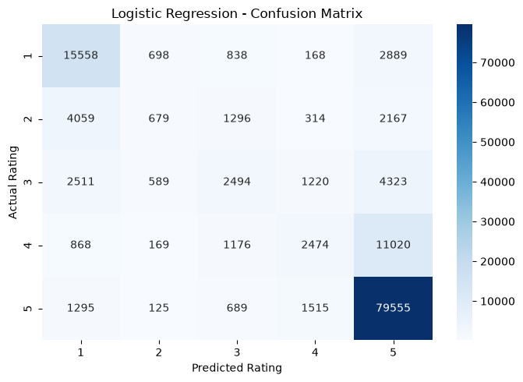
Figure 1. Logistic Regression confusion matrix from the supplied Week 6 evidence.
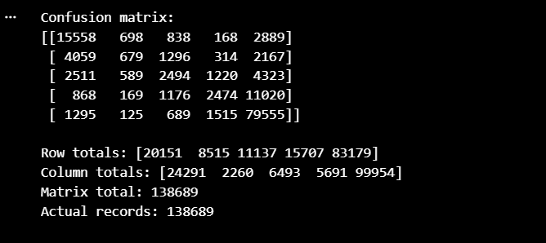
Figure 2. Verification output showing row totals, column totals, and the 138,689 matrix total.

6. Class-Level Classification Report

Rating 1
The classification report gives rating 1 precision 0.64, recall 0.77, F1-score 0.70, and support 20,151. The recall indicates that the model correctly identifies a substantial portion of actual one-star reviews. However, the confusion matrix also shows that some one-star reviews are predicted as five stars, and some predictions of one star actually belong to other classes.

Rating 2
For rating 2, precision is 0.30, recall is 0.08, F1-score is 0.13, and support is 8,515. This is the weakest recall among the five classes. The matrix shows only 679 correct predictions out of 8,515 actual two-star reviews. Many are classified as one star or five stars, so the model is poor at identifying this class in the current run.

Rating 3
For rating 3, precision is 0.38, recall is 0.22, F1-score is 0.28, and support is 11,137. The model correctly identifies 2,494 examples. Confusion with rating 5 is prominent, with 4,323 actual three-star reviews predicted as five stars. This limits the usefulness of the model for identifying moderate or mixed experiences.

Rating 4
For rating 4, precision is 0.43, recall is 0.16, F1-score is 0.23, and support is 15,707. The model correctly predicts 2,474 examples but predicts five stars for 11,020 actual four-star reviews. This suggests that many positive reviews are pushed toward the majority five-star label instead of preserving the distinction between four and five stars.

Rating 5
For rating 5, precision is 0.80, recall is 0.96, F1-score is 0.87, and support is 83,179. This is the strongest class by F1-score and recall. The model identifies most actual five-star reviews, but it also predicts five stars for many reviews with true ratings 2, 3, and 4. The large support of this class strongly influences the overall accuracy.

7. Output Files and Evidence

Evaluation metrics CSV
The notebook writes `data/processed/week6_evaluation_metrics.csv`. It contains the Logistic Regression model name and the four evaluation metrics. This file is useful for storing the results in a machine-readable form and comparing later experiments without copying values manually.

Classification report JSON
The file `data/processed/week6_logistic_regression_classification_report.json` stores class-level precision, recall, F1-score, support, and aggregate metrics generated by scikit-learn. It provides the detailed evidence behind the short metric summary and should be retained with the report.

Confusion matrix image
The file `visuals/week6_confusion_matrix.png` stores the heatmap of actual versus predicted rating classes. The supplied screenshot `05_week6_confusion_matrix.png` shows the matrix, and `06_confusion_matrix_verification.png` shows the printed matrix, row totals, column totals, matrix total, and actual-record count. These screenshots provide evidence that the final displayed matrix contains 138,689 records.

Notebook and folder organization
The notebook is `Week-6/week6_evaluation.ipynb`. The project should retain the notebook, README, final report, screenshots, metrics CSV, classification report JSON, and confusion-matrix image together. Use the same paths consistently in documentation. If the notebook is rerun after any code change, replace the old screenshots and outputs so the submission does not mix evidence from different runs.

8. Limitations and Improvement Recommendations

Imbalanced labels
The actual test set contains 83,179 five-star reviews and 8,515 two-star reviews. This imbalance can make the majority class easier to learn and can encourage overprediction of five stars. Macro metrics and class-level reports reveal this problem more clearly than accuracy alone. Future experiments could test class weighting or resampling within the training data, while leaving the test set untouched until final evaluation.

Ordinal nature of ratings
Star ratings are ordered: predicting 4 instead of 5 is not the same distance as predicting 1 instead of 5, even though ordinary classification accuracy counts both as one error. Future analysis could add mean absolute error of the numeric rating, weighted kappa, or another clearly defined ordinal metric. These would complement—not replace—the standard classification metrics and would need to be calculated from the same verified test predictions.

Text representation and language
TF-IDF captures token frequency patterns but does not fully understand context, sarcasm, negation, spelling variation, or multilingual text. The current vectorizer settings and model may therefore miss nuanced opinions. Future experiments could compare n-gram settings, character features, class weights, or a more advanced language representation. Each experiment should use a validation set or cross-validation for tuning and preserve the held-out test set for final comparison.

Training convergence
Week 5 recorded a Logistic Regression convergence warning at the maximum of 300 iterations. Week 6 evaluates the saved predictions and does not resolve that training warning by itself. If the model is retrained with a higher iteration limit or different solver, the new model must generate a new prediction CSV and all Week 6 metrics and charts must be regenerated. The new scores should be reported as a new run rather than silently replacing the existing ones.

Responsible interpretation
The classifier estimates ratings from review text and should not be described as understanding every customer experience or proving product quality. Its errors, especially for two-, three-, and four-star reviews, are substantial. The results are suitable as an educational baseline and for aggregate exploratory analysis, not as the sole basis for high-impact decisions about customers, products, sellers, or review authenticity.

9. Conclusion and Final Checklist

Conclusion
Week 6 completed the evaluation and verification stage using saved Week 5 predictions. The notebook calculated accuracy, macro precision, macro recall, and macro F1-score; generated a classification report and confusion matrix; and saved the evaluation outputs. The actual test record count, predicted record count, confusion-matrix total, and classification-report support all equal 138,689. The revised documentation corrects the previous 13,869 typo and reflects the verified notebook evidence.

Final findings
Logistic Regression achieved accuracy 72.65% and macro F1-score 44.18%. The model performs much better on rating 5 than on rating 2, and many four-star reviews are predicted as five stars. This uneven performance is the most important substantive finding. The model remains a baseline that could be improved through class-aware training, tuning, richer text features, and additional evaluation metrics.

Submission checklist
Before submitting, confirm that the prediction CSV has 138,689 rows; `actual_rating` and `logistic_regression_prediction` each have 138,689 non-missing values; the confusion-matrix total is 138,689; row totals match the actual rating counts; column totals sum to 138,689; metrics in the CSV match the notebook; the JSON report and image exist; and the report, README, notebook, and screenshots all describe the same run.

